# DoubleDutch API (Version 1.0)

The API provides a methods to retrieve data from EventsAIR.

Request and return values are in json format.

API base URL: “URL from App Store in EventsAIR”+/api

*How to Create the URL*:

1. Base URL = <https://nightly.eventsairtest.com/as-event-5/ddapi>
2. Break URL = “https://nightly.eventsairtest.com” {break} “/as-event-5/ddapi”
3. Add API URL = “https://nightly.eventsairtest.com” + “/DoubleDutchAPI” + “/as-event-5/ddapi” +/api
4. Full URL = <https://nightly.eventsairtest.com/DoubleDutchAPI/as-event-5/ddapi/api/GetAgendas>

The request must contain the following headers:

|  |  |  |
| --- | --- | --- |
| **Key** | **Value** | **Source** |
| ApiKey | {api key} | To be provided by Centium Software. |
| AppUserName | {portal user username} | Provided by the customer from the Portal User configured in the App Store in EventsAIR, by adding the DoubleDucth API App and configuring the settings and creating a user. |
| AppPassword | {portal user password} | Provided by the customer from the Portal User configured in the App Store in EventsAIR, by adding the DoubleDucth API App and configuring the settings and creating a user. |

**Notes for QA**

1. **In Chrome Web Store, add Postman**

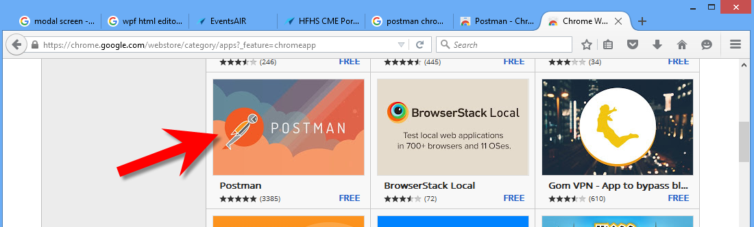

1. **Start up Postman. In Postman – Headers tab, add the following:**

* **ApiKey that can be used for testing:**
  + EwRC7hoJGlka7P7z9pycOUB67o43q6voNoQiZiNqF2nhxY7QSJDAR97mjWfWC6Iq3TMlOvNWKpTzx
* **AppUserName and AppPassword are from the app setup**:
  + AppUserName = Email Address
  + AppPassword = Password

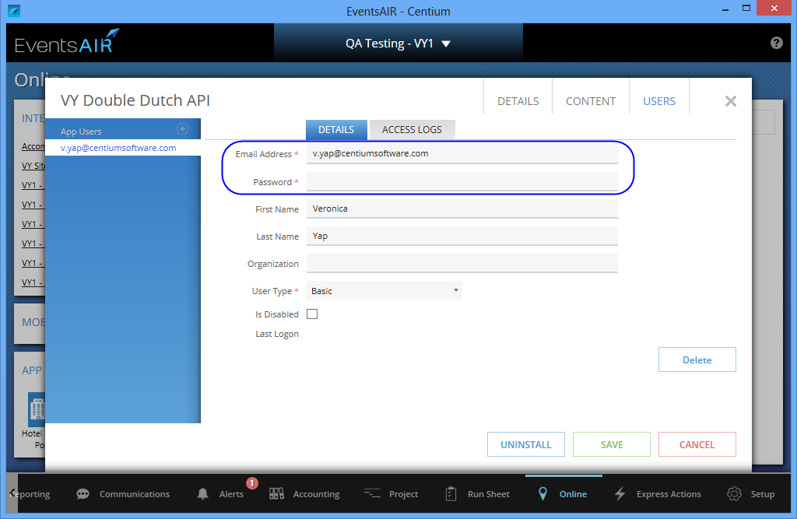

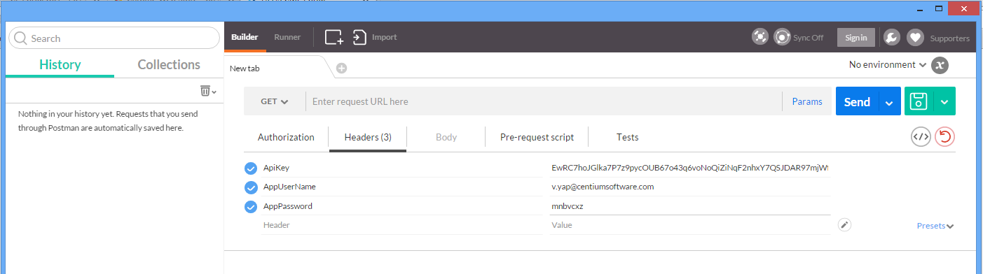

1. Depend on the Double Dutch API app setting, only attendees with the selected “item” are showing.

E.g. Attendees with the Registration Types selected should be returned in the GetAttendees api.

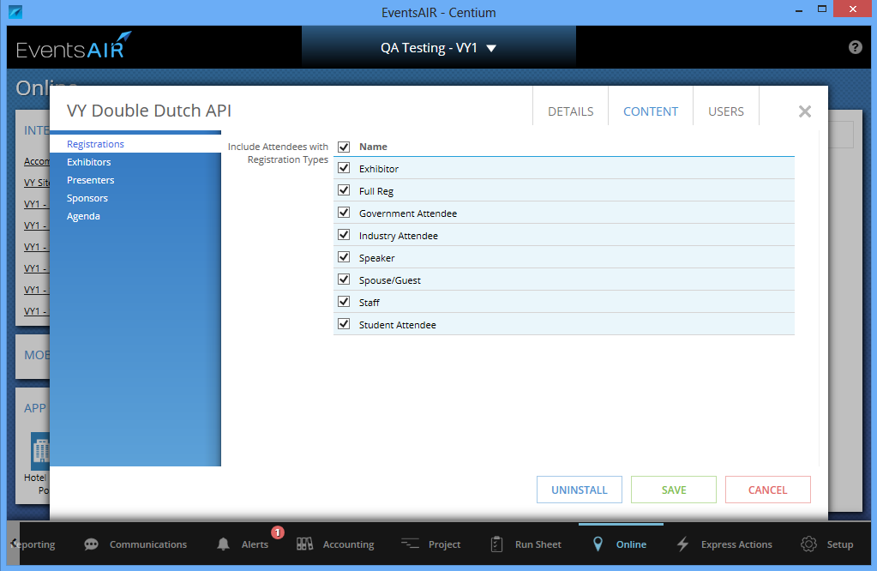

1. In Postman, refer to below screenshot

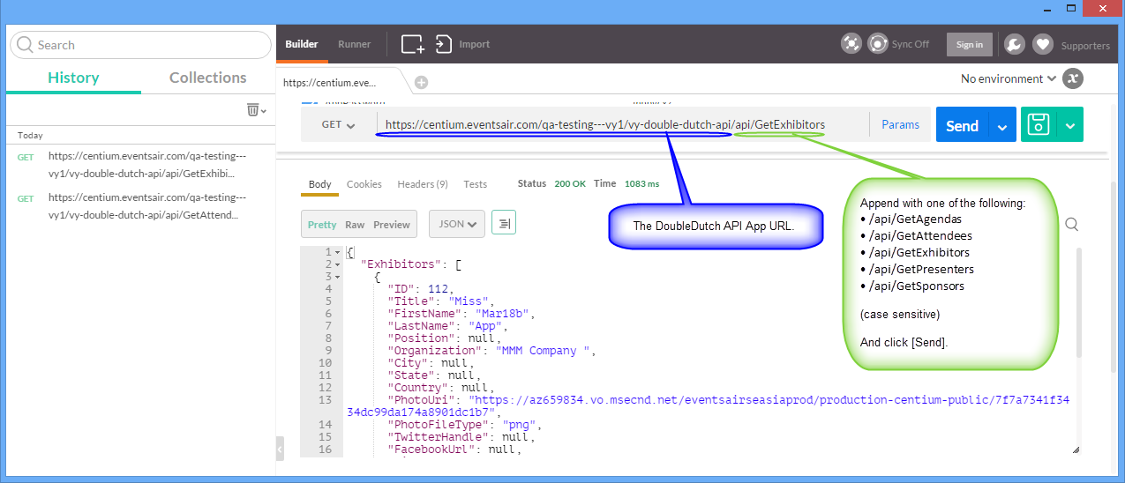

1. Below section of the document shows the fields that api returned.

## METHOD

**GetAttendees**

**GET**

**/GetAttendees**

Retrieves a collection of registered attendees from EventsAIR based on the configuration of the API in the App Store in EventsAIR.

**Return:**

Collection of Attendees objects.

**Attendees:**

| **Field** | **Type** | **Nullable** | **Description** |
| --- | --- | --- | --- |
| ID | int | No | Contact ID number |
| Title | String | Yes | Contact Title or Preferred Title from Registration if populated |
| FirstName | String | Yes | Contact First Name or Preferred First Name from Registration if populated |
| LastName | String | Yes | Contact Last Name or Preferred Last Name from Registration if populated |
| Position | String | Yes | Contact Position |
| Organization | String | Yes | Contact Organization |
| City | String | Yes | Contact Address City |
| State | String | Yes | Contact Address State |
| Country | String | Yes | Contact Address Country |
| PhotoUri | String | Yes | Uri to Photo Asset for Contact |
| PhotoFileType | String | Yes | File Type for PhotoUri |
| TwitterHandle | String | Yes | Contact Twitter Handle |
| FacebookUrl | String | Yes | Contact Facebook URL |
| LinkedInUrl | String | Yes | Contact LinkedIn URL |
| YouTubeUrl | String | Yes | Contact YouTube URL |
| GooglePlusUrl | String | Yes | Contact Google+ URL |
| PinterestUrl | String | Yes | Contact Pinterest URL |
| InstagramUrl | String | Yes | Contact Instagram URL |
| RegistrationType | String | No | Registration Type Name for Registration entry for Contact |

**json data example:**

The following example shows a contact with their registration and a partner registration attached to the same contact.

{

"Attendees": [

{

"ID": 3,

"Title": "Mr.",

"FirstName": "Corey",

“LastName": "Ali",

"Position": null,

"Organization": "Present Company",

"City": "Slochteren",

"State": "GR",

"Country": "Netherlands",

"PhotoUri": "https://az659631.vo.msecnd.net/eventsairauetest/test-doubledutchapi-public/9e569618a81f436eb7b2d60534687f0d",

"PhotoFileType": "jpg",

"TwitterHandle": "_eventsair",

"FacebookUrl": "www.facebook.com/eventsair",

"LinkedInUrl": "www.linkedin.com/company/centium-software",

"YouTubeUrl": "www.youtube.com/channel/UC5yqDtjKjD7byu_Nl5gOF4g",

"GooglePlusUrl": "plus.google.com/110759948495100720814/about?gclid=CPbDuN_Zu8gCFVglvQod7f0JUw",

"PinterestUrl": "www.pinterest.com/pin/260434790927210260/",

"InstagramUrl": null,

"RegistrationType": "Full Member Registration"

},

{

"ID": 3,

"Title": "Ms",

"FirstName": "Katie",

"LastName": "Ali",

"Position": null,

"Organization": null,

"City": "Slochteren",

"State": "GR",

"Country": "Netherlands",

"PhotoUri": null,

"PhotoFileType": null,

"TwitterHandle": null,

"FacebookUrl": null,

"LinkedInUrl": null,

"YouTubeUrl": null,

"GooglePlusUrl": null,

"PinterestUrl": null,

"InstagramUrl": null,

"RegistrationType": "Partner Registration"

}

]

}

## METHOD

**GetSponsors**

**GET**

**/GetSponsors**

Retrieves a collection of Sponsors from EventsAIR based on the configuration of the API in the App Store in EventsAIR.

**Return:**

Collection of Sponsors objects.

**Sponsors:**

| **Field** | **Type** | **Nullable** | **Description** |
| --- | --- | --- | --- |
| ID | Int | No | Contact ID number |
| Title | String | Yes | Contact Title |
| FirstName | String | Yes | Contact First Name |
| LastName | String | No | Contact Last Name |
| Position | String | Yes | Contact Position |
| Organization | String | Yes | Contact Organization |
| City | String | Yes | Contact Address City |
| State | String | Yes | Contact Address State |
| Country | String | Yes | Contact Address Country |
| PhotoUri | String | Yes | Uri to Photo Asset for Contact |
| PhotoFileType | String | Yes | File type extension for PhotoUri |
| TwitterHandle | String | Yes | Contact Twitter Handle |
| FacebookUrl | String | Yes | Contact Facebook URL |
| LinkedInUrl | String | Yes | Contact LinkedIn URL |
| YouTubeUrl | String | Yes | Contact YouTube URL |
| GooglePlusUrl | String | Yes | Contact Google+ URL |
| PinterestUrl | String | Yes | Contact Pinterest URL |
| InstagramUrl | String | Yes | Contact Instagram URL |
| LogoUri | String | Yes | Uri for Logo Asset for Sponsorship entry for Contact |
| LogoFileType | String | Yes | File type extension for LogoUri. |
| PackageName | String | No | Package Name for Sponsorship entry for Contact |
| Profile | String | Yes | Profile from Sponsorship entry for Contact |
| Brochures | Collection | No | Collection of Brochure documents assigned to the Sponsorship entry for Contact |

**Brochures:**

| **Field** | **Type** | **Nullable** | **Description** |
| --- | --- | --- | --- |
| Name | String | No | Name of Brochure entry from Sponsorship entry for Contact |
| Type | String | No | Document or Link |
| Uri | String | Yes | Uri for Brochure asset from brochure entry from Sponsorship entry for Contact, populated when Type is Document |
| FileType | String | Yes | File type extension for Uri, populated when Type is Document. |
| Link | String | Yes | URL from Brochure entry from Sponsorship entry for Contact, populated when type is Link |

**json data example:**

The following example shows a sponsor record without brochures and a sponsor record with multiple brochures that are for the same contact and a sponsor record with a single brochure.

{

"Sponsors": [

{

"ID": 121,

"Title": "Mr.",

"FirstName": "Walter",

"LastName": "Ford",

"Position": null,

"Organization": "Kids Mart",

"City": "Cullman",

"State": "AL",

"Country": "United States",

"PhotoUri": "https://az659631.vo.msecnd.net/eventsairauetest/test-doubledutchapi-public/66652f4604324ee38a97d8f4e0b25497",

"PhotoFileType": "jpg",

"TwitterHandle": "_eventsair",

"FacebookUrl": "www.facebook.com/eventsair",

"LinkedInUrl": "www.linkedin.com/company/centium-software",

"YouTubeUrl": "www.youtube.com/channel/UC5yqDtjKjD7byu_Nl5gOF4g",

"GooglePlusUrl": "plus.google.com/110759948495100720814/about?gclid=CPbDuN_Zu8gCFVglvQod7f0JUw",

"PinterestUrl": "www.pinterest.com/pin/260434790927210260/",

"InstagramUrl": null,

"LogoUri": "https://az659631.vo.msecnd.net/eventsairauetest/test-doubledutchapi-public/b2f66b087977436a8fc408e73c80c18d",

"LogoFileType": "jpg",

"PackageName": "Silver Package",

"Profile": null,

"Brochures": []

},

{

"ID": 121,

"Title": "Mr.",

"FirstName": "Walter",

"LastName": "Ford",

"Position": null,

"Organization": "Kids Mart",

"City": "Cullman",

"State": "AL",

"Country": "United States",

"PhotoUri": "https://az659631.vo.msecnd.net/eventsairauetest/test-doubledutchapi-public/66652f4604324ee38a97d8f4e0b25497",

"PhotoFileType": "jpg"

"TwitterHandle": "_eventsair",

"FacebookUrl": "www.facebook.com/eventsair",

"LinkedInUrl": "www.linkedin.com/company/centium-software",

"YouTubeUrl": "www.youtube.com/channel/UC5yqDtjKjD7byu_Nl5gOF4g",

"GooglePlusUrl": "plus.google.com/110759948495100720814/about?gclid=CPbDuN_Zu8gCFVglvQod7f0JUw",

"PinterestUrl": "www.pinterest.com/pin/260434790927210260/",

"InstagramUrl": null,

"LogoUri": "https://az659631.vo.msecnd.net/eventsairauetest/test-doubledutchapi-public/c0b7d7b0a7a74183b287f76b15d303ae",

"LogoFileType": "jpg",

"PackageName": "Platinum Package",

"Profile": "Kids Mart is an upscale consignment sales event. We have been serving the community for almost twenty years. Our goal is to offer our customers the largest selection of quality clothing at the most affordable prices.",

"Brochures": [

{

"Name": "Kids Mart",

"Type": "Document",

"Uri": "https://az659631.vo.msecnd.net/eventsairauetest/test-doubledutchapi-public/898c9def620046bdaff96a9173e0c974",

"FileType": "pdf",

"Link": null

},

{

"Name": "Kids Mart Website",

"Type": "Link",

"Uri": null,

"FileType": null,

"Link": "http://www.cullmankidsmart.com/index.html"

}

]

},

{

"ID": 122,

"Title": "Mr.",

"FirstName": "Aidan",

"LastName": "Forlong",

"Position": null,

"Organization": "Pro Property Maintenance",

"City": "Avonhead",

"State": "Christchurch",

"Country": "New Zealand",

"PhotoUri": "https://az659631.vo.msecnd.net/eventsairauetest/test-doubledutchapi-public/9cb4415120fd41d8b553dcf3d69dbe6c",

"PhotoFileType": "jpg",

"TwitterHandle": null,

"FacebookUrl": null,

"LinkedInUrl": null,

"YouTubeUrl": null,

"GooglePlusUrl": null,

"PinterestUrl": null,

"InstagramUrl": null,

"LogoUri": "https://az659631.vo.msecnd.net/eventsairauetest/test-doubledutchapi-public/2caf111c6bba4b5aa47bddea41b0467c",

"LogoFileType": "jpg",

"PackageName": "Platinum Package",

"Profile": "",

"Brochures": [

{

"Name": "Website",

"Type": "Link",

"Uri": null,

"FileType": null,

"Link": "http://www.ppms.com.au/"

}

]

}

]

}

## METHOD

**GetExhibitors**

**GET**

**/GetExhibitors**

Retrieves a collection of Exhibitors from EventsAIR based on the configuration of the API in the App Store in EventsAIR.

**Return:**

Collection of Exhibitors objects.

**Exhibitors:**

| **Field** | **Type** | **Nullable** | **Description** |
| --- | --- | --- | --- |
| ID | Int | No | Contact ID number |
| Title | String | Yes | Contact Title |
| FirstName | String | Yes | Contact First Name |
| LastName | String | No | Contact Last Name |
| Position | String | Yes | Contact Position |
| Organization | String | Yes | Contact Organization |
| City | String | Yes | Contact Address City |
| State | String | Yes | Contact Address State |
| Country | String | Yes | Contact Address Country |
| PhotoUri | String | Yes | Uri to Photo Asset for Contact |
| PhotoFileType | String | Yes | File type extension for PhotoUri |
| TwitterHandle | String | Yes | Contact Twitter Handle |
| FacebookUrl | String | Yes | Contact Facebook URL |
| LinkedInUrl | String | Yes | Contact LinkedIn URL |
| YouTubeUrl | String | Yes | Contact YouTube URL |
| GooglePlusUrl | String | Yes | Contact Google+ URL |
| PinterestUrl | String | Yes | Contact Pinterest URL |
| InstagramUrl | String | Yes | Contact Instagram URL |
| LogoUri | String | Yes | Uri for Logo Asset for Exhibition entry for Contact |
| LogoFileType | String | Yes | File type extension for LogoUri |
| StandNumber | String | Yes | Stand Number for Exhibition entry for Contact |
| StandType | String | No | Stand Type Name for Exhibition entry for Contact |
| StandSignage | String | Yes | Signage for Exhibition entry for Contact |
| Profile | String | Yes | Profile for Exhibition entry for Contact |
| Brochures | Collection | No | Collection of Brochure documents assigned to the Exhibition entry for Contact |

**Brochures:**

| **Field** | **Type** | **Mandatory** | **Description** |
| --- | --- | --- | --- |
| Name | String | No | Name of Brochure entry from Exhibition entry for Contact |
| Type | String | No | Document or Link |
| Uri | String | Yes | Uri for Brochure asset from brochure entry from Exhibition entry for Contact, populated when Type is Document |
| FileType | String | Yes | File type extension for Uri, populated when Type is Document. |
| Link | String | Yes | URL from Brochure entry from Exhibition entry for Contact, populated when type is Link |

**json data example:**

The following example shows an exhibitor record without brochures for a contact and an exhibitor record with a single brochure and an exhibitor record with multiple brochures that are for the same contact.

{

"Exhibitors": [

{

"ID": 120,

"Title": "Mrs.",

"FirstName": "Anna",

"LastName": "Forbes",

"Position": null,

"Organization": "Jewel Mart",

"City": "Hirtshals",

"State": "Region Nordjylland",

"Country": "Denmark",

"PhotoUri": "https://az659631.vo.msecnd.net/eventsairauetest/test-doubledutchapi-public/0f24b11f407e4a2c9e8156777de64eee",

"PhotoFileType": "jpg",

"TwitterHandle": null,

"FacebookUrl": null,

"LinkedInUrl": null,

"YouTubeUrl": null,

"GooglePlusUrl": null,

"PinterestUrl": null,

"InstagramUrl": null,

"LogoUri": null,

"LogoFileType": null,

"StandNumber": "14",

"StandType": "Standard",

"StandSignage": null,

"Profile": null,

"Brochures": []

},

{

"ID": 121,

"Title": "Mr.",

"FirstName": "Walter",

"LastName": "Ford",

"Position": null,

"Organization": "Kids Mart",

"City": "Cullman",

"State": "AL",

"Country": "United States",

"PhotoUri": "https://az659631.vo.msecnd.net/eventsairauetest/test-doubledutchapi-public/66652f4604324ee38a97d8f4e0b25497",

"PhotoFileType": "jpg",

"TwitterHandle": "_eventsair",

"FacebookUrl": "www.facebook.com/eventsair",

"LinkedInUrl": "www.linkedin.com/company/centium-software",

"YouTubeUrl": "www.youtube.com/channel/UC5yqDtjKjD7byu_Nl5gOF4g",

"GooglePlusUrl": "plus.google.com/110759948495100720814/about?gclid=CPbDuN_Zu8gCFVglvQod7f0JUw",

"PinterestUrl": "www.pinterest.com/pin/260434790927210260/",

"InstagramUrl": null,

"LogoUri": null,

"LogoFileType": null,

"StandNumber": "19",

"StandType": "Double",

"StandSignage": "KIds Mart Online",

"Profile": "Kids Mart is an upscale consignment sales event. We have been serving the community for almost twenty years. Our goal is to offer our customers the largest selection of quality clothing at the most affordable prices. Now with an Online store.",

"Brochures": [

{

"Name": "Website",

"Type": "Link",

"Uri": null,

"FileType": null,

"Link": "http://www.cullmankidsmart.com/"

}

]

},

{

"ID": 121,

"Title": "Mr.",

"FirstName": "Walter",

"LastName": "Ford",

"Position": null,

"Organization": "Kids Mart",

"City": "Cullman",

"State": "AL",

"Country": "United States",

"PhotoUri": "https://az659631.vo.msecnd.net/eventsairauetest/test-doubledutchapi-public/66652f4604324ee38a97d8f4e0b25497",

"PhotoFileType": "jpg",

"TwitterHandle": "_eventsair",

"FacebookUrl": "www.facebook.com/eventsair",

"LinkedInUrl": "www.linkedin.com/company/centium-software",

"YouTubeUrl": "www.youtube.com/channel/UC5yqDtjKjD7byu_Nl5gOF4g",

"GooglePlusUrl": "plus.google.com/110759948495100720814/about?gclid=CPbDuN_Zu8gCFVglvQod7f0JUw",

"PinterestUrl": "www.pinterest.com/pin/260434790927210260/",

"InstagramUrl": null,

"LogoUri": "https://az659631.vo.msecnd.net/eventsairauetest/test-doubledutchapi-public/55fcf1ce098c45359c45a498933b1d16",

"LogoFileType": "jpg",

"StandNumber": "15",

"StandType": "Double",

"StandSignage": "Kids Mart",

"Profile": "Kids Mart is an upscale consignment sales event. We have been serving the community for almost twenty years. Our goal is to offer our customers the largest selection of quality clothing at the most affordable prices.",

"Brochures": [

{

"Name": "Company Website",

"Type": "Link",

"Uri": null,

"FileType": null,

"Link": "http://www.cullmankidsmart.com/"

},

{

"Name": "Fall 2015",

"Type": "Document",

"Uri": "https://az659631.vo.msecnd.net/eventsairauetest/test-doubledutchapi-public/f69731190ffc4957941937d0e935dc13",

"FileType": "pdf",

"Link": null

}

]

}

]

}

## METHOD

**GetPresenters**

**GET**

**/GetPresenters**

Retrieves a collection of Presenters from EventsAIR based on the configuration of the API in the App Store in EventsAIR.

**Return:**

Collection of Presenters objects.

**Presenters:**

| **Field** | **Type** | **Nullable** | **Description** |
| --- | --- | --- | --- |
| ID | Int | No | Contact ID number |
| Title | String | Yes | Contact Title |
| FirstName | String | Yes | Contact First Name |
| LastName | String | No | Contact Last Name |
| Position | String | Yes | Contact Position |
| Organization | String | Yes | Contact Organization |
| City | String | Yes | Contact Address City |
| State | String | Yes | Contact Address State |
| Country | String | Yes | Contact Address Country |
| PhotoUri | String | Yes | Uri to Photo Asset for Contact |
| PhotoFileType | String | Yes | File type extension for PhotoUri |
| TwitterHandle | String | Yes | Contact Twitter Handle |
| FacebookUrl | String | Yes | Contact Facebook URL |
| LinkedInUrl | String | Yes | Contact LinkedIn URL |
| YouTubeUrl | String | Yes | Contact YouTube URL |
| GooglePlusUrl | String | Yes | Contact Google+ URL |
| PinterestUrl | String | Yes | Contact Pinterest URL |
| InstagramUrl | String | Yes | Contact Instagram URL |
| PaperTitle | String | No | Paper Title for Presentation entry for Contact |
| PaperNumber | Int | Yes | Paper Number for Presentation entry for Contact |
| PaperReference | String | Yes | Paper Reference for Presentation entry for Contact |
| Theme | String | Yes | Theme Name for Presentation entry for Contact |
| SubTheme | String | Yes | Sub Theme Name for Presentation entry for Contact |
| PresentationType | String | Yes | Presentation Type Name for Presentation entry for Contact |
| Biography | String | Yes | Biography for Presentation entry for Contact |
| SessionName | String | Yes | Session Name for Presentation entry for Contact |
| SessionDate | String | Yes | Session Date for Presentation Entry for Contact in the format yyyy-mm-dd |
| SessionStartTime | String | Yes | Session Start Time for Presentation entry for Contact in the format hhmm |
| SessionEndTime | String | Yes | Session End Time for Presentation entry for Contact in the format hhmm |
| SessionRoom | String | Yes | Session Room Name for Presentation entry for Contact |
| SessionTrack | Int | Yes | Session Track number for Presentation entry for Contact |
| PresentationStartTime | String | Yes | Presentation Start Time for Presentation entry for Contact in the format hhmm |
| PresentationEndTime | String | Yes | Presentation End Time for Presentation entry for Contact in the format hhmm |
| PresentationOrder | Int | No | Presentation Order number for Presentation entry for Contact |
| PosterBoardNumber | String | Yes | Poster Board Number for Presentation entry for Contact |
| Documents | Collection | No | Collection of Documents from Presentation entry for Contact |
| Authors | Collection | No | Collection of Authors for Presentation entry for Contact |
| Affiliations | Collection | No | Collection of Affiliations for Presentation entry for Contact |

**Documents:**

| **Field** | **Type** | **Nullable** | **Description** |
| --- | --- | --- | --- |
| Name | String | No | Name of Document entry for Presentation entry for Contact |
| Uri | String | Yes | Uri for Document asset from Document entry for Presentation entry for Contact, populated when Type is Pdf, UploadedDocument or Image |
| FileType | String | Yes | File type extension for Uri |
| Type | String | No | Pdf  UploadedDocument  PlainText  Image  Link  Html (currently not supported) |
| TextContent | String | Yes | Text content from Document entry for Presentation entry for Contact, populated when Type is PlainText or Link |
| HtmlContent | String | Yes | Html content from Document entry for Presentation entry for Contact, populated when type is Html (currently not supported) |

**Authors:**

| **Field** | **Type** | **Nullable** | **Description** |
| --- | --- | --- | --- |
| Title | String | Yes | Title from Author entry for Presentation entry for Contact |
| FirstName | String | Yes | First Name from Author entry for Presentation entry for Contact |
| LastName | String | No | Last Name from Author entry for Presentation entry for Contact |
| Position | String | Yes | Position from Author entry for Presentation entry for Contact |
| Affiliations | String | Yes | Comma delimited list of Affiliation numbers from Author entry for Presentation entry for Contact |
| Presenting | Bool | No | Presenting from Author entry for Presentation entry for Contact |
| Order | Int | Yes | Order from Author entry for Presentation entry for Contact |

**Affiliations:**

| **Field** | **Type** | **Nullable** | **Description** |
| --- | --- | --- | --- |
| Number | Int | No | Number from Affiliation entry for Presentation entry for Contact |
| Organization | String | No | Organization from Affiliation entry for Presentation entry for Contact |
| City | String | Yes | City from Affiliation entry for Presentation entry for Contact |
| State | String | Yes | State from Affiliation entry for Presentation entry for Contact |
| Country | String | Yes | Country from Affiliation entry for Presentation entry for Contact |

**json data example:**

The following example show a presenter record with no affiliations, a presenter record with multiple documents and authors, a presenter record for the same contact as the previous presenter record and a presenter record with multiple affiliations.

{

"Presenters": [

{

"ID": 217,

"Title": "Mr.",

"FirstName": "Tim",

"LastName": "Winton",

"Position": null,

"Organization": "Friendly Interior Design",

"City": "Szczecin",

"State": null,

"Country": "Poland",

"PhotoUri": null,

"PhotoFileType": null,

"TwitterHandle": null,

"FacebookUrl": null,

"LinkedInUrl": null,

"YouTubeUrl": null,

"GooglePlusUrl": null,

"PinterestUrl": null,

"InstagramUrl": null,

"PaperTitle": "Pattern Dynamics Theory",

"PaperNumber": 11,

"PaperReference": null,

"Theme": null,

"SubTheme": null,

"PresentationType": "Oral",

"Biography": "Tim’s background is in the sustainability sector. Over the last 20 years he has worked in sustainability in various capacities: as a handson contractor within the reforestation industry, organic farmer, not-for-profit founder, company director, educator, designer and consultant. He developed PatternDynamics™ as a method of understanding natural systems and for leveraging those understandings in managing complexity. Translating natural patterns into sustainability tools is his life’s work and overriding passion. Tim is an independent Integral scholar-practitioner who has published articles in the Journal of Integral Theory and Practice, as part of the proceedings of Integral Academic Conferences and Practitioner Seminars and as a contributor to the edited volume, Integral Theory in Action: Applied, Theoretical, and Critical Perspectives on the AQAL Model (in press). Tim speaks and writes regularly on sustainability topics. Tim holds a BA in English Literature, a Diploma of Permaculture Design and a Certificate 4 in Workplace Training and Assessment.",

"SessionName": "Systems and People",

"SessionDate": "2015-11-10",

"SessionStartTime": "0900",

"SessionEndTime": "1200",

"SessionRoom": "Conference Room A",

"SessionTrack": 4,

"PresentationStartTime": "0900",

"PresentationEndTime": "1000",

"PresentationOrder": 1,

"PosterBoardNumber": null,

"Documents": [

{

"Name": "Abstract",

"Uri": null,

"FileType": null,

"Type": "PlainText",

"TextContent": "During this session, Tim Winton, PatternDynamics™ founder, will lead a short interactive workshop process introducing a\r\nmethod of collaborative systems thinking based on the sustainable patterns of natural ecosystems.\r\nPatternDynamics™ is a simple tool that can be learned by anyone to overcome the challenges posed by complex systems–at any scale. Here’s how it works:\r\n• The key to complexity is systems thinking;\r\n• The key to systems thinking is Patterns; and,\r\n• The key to using Patterns collaboratively is to form them into a language.\r\nPatternDynamics™is a Sustainability Pattern Language: our current spoken, written and mathematical languages are excellent for analyzing the nature of ‘parts’, but they are not optimized for helping us see how these parts are connected and organized as ‘wholes’.\r\nBy combining the patterns of nature with the power of language, PatternDynamics™ creates a Sustainability Pattern Language – a language of wholistic symbols designed to help us develop the systems thinking capacity needed to meet the challenges of creating a sustainable world.",

"HtmlContent": null

}

],

"Authors": [

{

"Title": "Mr.",

"FirstName": "Tim",

"LastName": "Winton",

"Position": null,

"Affiliations": null,

"Presenting": true,

"Order": 1

}

],

"Affiliations": []

},

{

"ID": 215,

"Title": "Mr.",

"FirstName": "Tom",

"LastName": "Davies",

"Position": null,

"Organization": "The Sample",

"City": "LLANCARFAN",

"State": null,

"Country": "United Kingdom",

"PhotoUri": "https://az659631.vo.msecnd.net/eventsairauetest/test-doubledutchapi-public/a054521dee75488ea23b800c11c72da4",

"PhotoFileType": “jpg”,

"TwitterHandle": null,

"FacebookUrl": null,

"LinkedInUrl": null,

"YouTubeUrl": null,

"GooglePlusUrl": null,

"PinterestUrl": null,

"InstagramUrl": null,

"PaperTitle": "Resilient housing for Lake Macquarie",

"PaperNumber": 8,

"PaperReference": "EE01",

"Theme": "Impact",

"SubTheme": "Environmental",

"PresentationType": "Oral",

"Biography": null,

"SessionName": "Environmental Efficiency",

"SessionDate": "2015-11-10",

"SessionStartTime": "1300",

"SessionEndTime": "1700",

"SessionRoom": "Ballroom 2",

"SessionTrack": 3,

"PresentationStartTime": "1300",

"PresentationEndTime": "1500",

"PresentationOrder": 1,

"PosterBoardNumber": "",

"Documents": [

{

"Name": "Abstract",

"Uri": null,

"FileType": null,

"Type": "PlainText",

"TextContent": "The highly urbanised foreshore surrounding Lake Macquarie is at risk from the increased frequency and severity of flooding events and permanent inundation from sea level rise. Developments in at-risk areas such as the Lake Macquarie foreshore need to be resilient to the changing hazards with inbuilt adaptability and flexibility to allow continued occupation for the lifetime of the development. Guidelines for resilient housing allow local governments to assess development in high risk areas against design principles for resilience, and provide performance criteria to ensure developments are capable of being adaptable and flexible. This kind of planning for the future means desirable coastal land need not be sterilised due to predicted risk and prevents legacy issues of unliveable coastal development. Lake Macquarie City Council commissioned Edge Environment to produce “Development Guidelines for Resilient Housing for Lake Macquarie”. Resilient housing can be easily re-configured to respond to a change in hazard, if and when required. It allows the building to function safely over a range of scenarios, and the investment in additional risk mitigation can be timed to coincide with the increase in hazard, which may occur faster or slower than predicted. It may also allow construction in areas of high risk, where other buildings would fail or become dysfunctional. The Guidelines will be integrated into a Development Control Plan to give developers direction on acceptable solutions for building in areas impacted by predicted sea level rise. This project sets a precedent for local government action on adapting the built environment to potential risk to sea level rise.",

"HtmlContent": null

},

{

"Name": "Bio",

"Uri": "https://az659631.vo.msecnd.net/eventsairauetest/test-doubledutchapi-public/68a88b2635f14feebdcd098d7e918b15",

"FileType": "docx",

"Type": "UploadedDocument",

"TextContent": null,

"HtmlContent": null

},

{

"Name": "Company Logo",

"Uri": "https://az659631.vo.msecnd.net/eventsairauetest/test-doubledutchapi-public/c9d6e3934bda463ab0a94eae092e53fb",

"FileType": "png",

"Type": "Image",

"TextContent": null,

"HtmlContent": null

},

{

"Name": "PDF",

"Uri": "https://az659631.vo.msecnd.net/eventsairauetest/test-doubledutchapi-public/d9d8635595f2453081af4c44e5c00020",

"FileType": "pdf",

"Type": "Pdf",

"TextContent": null,

"HtmlContent": null

},

{

"Name": "Website",

"Uri": null,

"FileType": null,

"Type": "Link",

"TextContent": "http://www.centiumsoftware.com",

"HtmlContent": null

}

],

"Authors": [

{

"Title": "Mr.",

"FirstName": "Tom",

"LastName": "Davies",

"Position": null,

"Affiliations": "1",

"Presenting": true,

"Order": 1

},

{

"Title": null,

"FirstName": "Sarah",

"LastName": "Campbell",

"Position": null,

"Affiliations": "1",

"Presenting": true,

"Order": 2

}

],

"Affiliations": [

{

"Number": 1,

"Organization": "MEIANZ",

"City": null,

"State": null,

"Country": null

}

]

},

{

"ID": 215,

"Title": "Mr.",

"FirstName": "Tom",

"LastName": "Davies",

"Position": null,

"Organization": "The Sample",

"City": "LLANCARFAN",

"State": null,

"Country": "United Kingdom",

"PhotoUri": "https://az659631.vo.msecnd.net/eventsairauetest/test-doubledutchapi-public/a054521dee75488ea23b800c11c72da4",

"PhotoFileType": "jpg",

"TwitterHandle": null,

"FacebookUrl": null,

"LinkedInUrl": null,

"YouTubeUrl": null,

"GooglePlusUrl": null,

"PinterestUrl": null,

"InstagramUrl": null,

"PaperTitle": "Who are the certifiable climate change professionals?",

"PaperNumber": 21,

"PaperReference": null,

"Theme": null,

"SubTheme": null,

"PresentationType": "Workshop",

"Biography": null,

"SessionName": "Climate Change Professionals",

"SessionDate": "2015-11-11",

"SessionStartTime": "0900",

"SessionEndTime": "1200",

"SessionRoom": "Ballroom 1",

"SessionTrack": 2,

"PresentationStartTime": "0900",

"PresentationEndTime": "1200",

"PresentationOrder": 1,

"PosterBoardNumber": null,

"Documents": [

{

"Name": "Abstract",

"Uri": null,

"FileType": null,

"Type": "PlainText",

"TextContent": "At the 2012 EIANZ Annual conference, the EIANZ Climate Change Special Interest Section (CCSIS) Executive hosted a workshop exploring the member interest in, and the potential process behind development of a system for Professional Certification of Climate Change Practitioners in New Zealand and Australia. The outcomes included a strong level of interest and support for the Climate Change SIS to progress with developing a scheme, modelled on the existing EIANZ’s CEnvP approach.\r\nThe CCSIS progressed this work with key decisions being to:\r\n• Initially include the climate change practitioner certification as a ‘specialty’ within the existing CEnvP program along with the existing ‘general’, ‘impact assessment and ‘ecology’ specialties\r\n• Support potential applicants for certification with an EIANZ administered climate change skills and knowledge development training program\r\n• Use the success and learning of the EIANZ’s ‘Learning to adapt’ program of five NSW events as a basis for extending climate change learning to all EIANZ divisional areas, and\r\n• Develop assessable competency criteria for use by review panels and approval by the existing CEnvP Board.\r\nThe objectives of the 2013 conference workshop are to:\r\n1. Provide opportunity for EIANZ members to learn about opportunities to become involved in the delivery of certification or prepare to nominate for certification\r\n2. Provide an opportunity for EIANZ members to program to help refine the approach to establishment of the climate change certification program before the first call for nominations in January 2014\r\n3. Discuss the proposed evaluation criteria and processes, and\r\n4. Discus climate change professional development and the role of EIANZ’s ‘Learning to adapt’ and “Steps” program in supporting progression towards and maintenance of climate change practitioner certification",

"HtmlContent": null

}

],

"Authors": [

{

"Title": "Mr.",

"FirstName": "Tom",

"LastName": "Davies",

"Position": null,

"Affiliations": "1",

"Presenting": true,

"Order": 1

}

],

"Affiliations": [

{

"Number": 1,

"Organization": "MEIANZ",

"City": null,

"State": null,

"Country": null

}

]

},

{

"ID": 219,

"Title": "Mr.",

"FirstName": "Alastair",

"LastName": "Buchan",

"Position": null,

"Organization": "Laneco",

"City": "Holte",

"State": "Region Sjælland",

"Country": "Denmark",

"PhotoUri": "https://az659631.vo.msecnd.net/eventsairauetest/test-doubledutchapi-public/7ead77045195457180c8853282fa896d",

"PhotoFileType": "jpg",

"TwitterHandle": null,

"FacebookUrl": null,

"LinkedInUrl": null,

"YouTubeUrl": null,

"GooglePlusUrl": null,

"PinterestUrl": null,

"InstagramUrl": null,

"PaperTitle": "Triple threat regional planning - finding the x factor for an all singing, all dancing and all action outcome",

"PaperNumber": 13,

"PaperReference": null,

"Theme": null,

"SubTheme": null,

"PresentationType": "Oral",

"Biography": null,

"SessionName": "Strategic Planning",

"SessionDate": "2015-11-10",

"SessionStartTime": "0900",

"SessionEndTime": "1200",

"SessionRoom": "Ballroom 3",

"SessionTrack": 2,

"PresentationStartTime": "1000",

"PresentationEndTime": "1100",

"PresentationOrder": 2,

"PosterBoardNumber": null,

"Documents": [

{

"Name": "Abstract",

"Uri": null,

"FileType": null,

"Type": "PlainText",

"TextContent": "Alastair has a background in systems ecology and water science. After nearly30 years managing natural resource issues, he has extensive experience as a staff and project team manager in policy, strategy and action plan development. Currently he is the NRM planning coordinator for the Burdekin Regional Queensland region working for the NGO - NQ Dry Tropics in Townsville. This works focuses on strategic plan renewal and incorporation of climate change considerations into public NRM and regional development investment strategies.\r\nAlastair specializes in solving ‘wicked’ problems and creating new organisational networks and processes for more sustainable outcomes. For example, in 2010 he was the Director of water planning policy with the Murray Darling Basin Authority in Canberra Australia. In this role he had accountability for integrating the water resource planning process for five states and for developing draft statutory requirements for climate change policy. He has also worked as a practitioner and manager in the livestock and wildlife industries, on vegetation, threatened species, biodiversity, water quality, wetlands, hydrology, hydrogeology, soils, energy and green-house gas emissions and climate change adaptation.\r\nAlastair is a certified environmental practitioner with strong technical and scientific background (MSc. In systems ecology) is balanced with practical experience in academic, charity, multi-national and local, state and federal government organisations. This gives him a special talent for applying systems thinking and demand management approaches to highly complex situations.",

"HtmlContent": null

}

],

"Authors": [

{

"Title": "Mr.",

"FirstName": "Alastair",

"LastName": "Buchan",

"Position": null,

"Affiliations": "1,2",

"Presenting": true,

"Order": 0

}

],

"Affiliations": [

{

"Number": 1,

"Organization": "MEIANZ",

"City": null,

"State": null,

"Country": null

},

{

"Number": 2,

"Organization": "CEnvP",

"City": null,

"State": null,

"Country": null

}

]

}

]

}

## METHOD

**GetAgendas**

**GET**

**/GetAgendas**

Retrieves a collection of Agendas from EventsAIR based on the configuration of the API in the App Store in EventsAIR.

**Return:**

Collection of Agendas objects.

**Agendas:**

| **Field** | **Type** | **Nullable** | **Description** |
| --- | --- | --- | --- |
| Name | String | No | Agenda item Name |
| Date | String | No | Agenda item Date in the format yyyy-mm-dd |
| StartTime | String | No | Agenda item Start Time in format hhmm |
| EndTime | String | No | Agenda item End Time in format hhmm |
| Overview | String | Yes | Agenda item Overview |
| Details | String | Yes | Agenda item Details |
| Track | Int | Yes | Agenda item Track |
| Location | String | Yes | Agenda item Location Name |
| PublishOnline | Boolean | No | Agenda item Publish Online, true or false |
| TextColor | String | No | Agenda item Text Color in Hex format including # |
| BackgroundColor | String | No | Agenda item Background Color in Hex format including # |
| Bold | Boolean | No | Agenda item Text Bold, true or false |
| Comment | String | Yes | Agenda item Comment |
| Type | String | No | Agenda item type, can be one of the following:  Heading  Function  Session  ConcurrentSession  BreakActivity  Information |
| SessionPresentationDetails |  | No | Session Presentation Details is a collection of Chairpersons and Presenters when the type is Session or ConcurrentSession |

**SessionPresentationDetails:**

| **Field** | **Type** | **Nullable** | **Description** |
| --- | --- | --- | --- |
| Chairpersons | Collection | No | Collection of the Chairpersons for the Session or Concurrent Session |
| Presenters | Collection | No | Collection of the Presenters for the Session or Concurrent Session |

**Chairpersons:**

| **Field** | **Type** | **Nullable** | **Description** |
| --- | --- | --- | --- |
| ID | Int | No | Contact ID for Chairperson linked to the Session or Concurrent Session |
| Title | String | Yes | Contact Title for Chairperson linked to the Session or Concurrent Session |
| FirstName | String | Yes | Contact First Name for Chairperson linked to the Session or Concurrent Session |
| LastName | String | Yes | Contact Last Name for Chairperson linked to the Session or Concurrent Session |
| Position | String | Yes | Contact Position for Chairperson linked to the Session or Concurrent Session |
| Organization | String | Yes | Contact Organization for Chairperson linked to the Session or Concurrent Session |
| City | String | Yes | Contact Address City for Chairperson linked to the Session or Concurrent Session |
| State | String | Yes | Contact Address State for Chairperson linked to the Session or Concurrent Session |
| Country | String | Yes | Contact Address Country for Chairperson linked to the Session or Concurrent Session |
| PhotoUri | String | Yes | Uri to Photo Asset for Contact for Chairperson linked to the Session or Concurrent Session |
| PhotoFileType | String | Yes | File type extension for PhotoUri |
| TwitterHandle | String | Yes | Contact Twitter Handle for Chairperson linked to the Session or Concurrent Session |
| FacebookUrl | String | Yes | Contact Facebook URL for Chairperson linked to the Session or Concurrent Session |
| LinkedInUrl | String | Yes | Contact LinkedIn URL for Chairperson linked to the Session or Concurrent Session |
| YouTubeUrl | String | Yes | Contact YouTube URL for Chairperson linked to the Session or Concurrent Session |
| GooglePlusUrl | String | Yes | Contact Google+ URL for Chairperson linked to the Session or Concurrent Session |
| PinterestUrl | String | Yes | Contact Pinterest URL for Chairperson linked to the Session or Concurrent Session |
| InstagramUrl | String | Yes | Contact Instagram URL for Chairperson linked to the Session or Concurrent Session |
| Comment | String | Yes | Chairperson Comment for Chairperson linked to the Session or Concurrent Session |

**Presenters:**

| **Field** | **Type** | **Nullable** | **Description** |
| --- | --- | --- | --- |
| ID | Int | No | Contact ID number for Presentation linked to the Session or Concurrent Session |
| Title | String | Yes | Contact Title for Presentation linked to the Session or Concurrent Session |
| FirstName | String | Yes | Contact First Name for Presentation linked to the Session or Concurrent Session |
| LastName | String | No | Contact Last Name for Presentation linked to the Session or Concurrent Session |
| Position | String | Yes | Contact Position for Presentation linked to the Session or Concurrent Session |
| Organization | String | Yes | Contact Organization for Presentation linked to the Session or Concurrent Session |
| City | String | Yes | Contact Address City for Presentation linked to the Session or Concurrent Session |
| State | String | Yes | Contact Address State for Presentation linked to the Session or Concurrent Session |
| Country | String | Yes | Contact Address Country for Presentation linked to the Session or Concurrent Session |
| PhotoUri | String | Yes | Uri to Photo Asset for Contact for Presentation linked to the Session or Concurrent Session |
| PhotoFileType | String | Yes | File type extension for PhotoUri |
| TwitterHandle | String | Yes | Contact Twitter Handle for Presentation linked to the Session or Concurrent Session |
| FacebookUrl | String | Yes | Contact Facebook URL for Presentation linked to the Session or Concurrent Session |
| LinkedInUrl | String | Yes | Contact LinkedIn URL for Presentation linked to the Session or Concurrent Session |
| YouTubeUrl | String | Yes | Contact YouTube URL for Presentation linked to the Session or Concurrent Session |
| GooglePlusUrl | String | Yes | Contact Google+ URL for Presentation linked to the Session or Concurrent Session |
| PinterestUrl | String | Yes | Contact Pinterest URL for Presentation linked to the Session or Concurrent Session |
| InstagramUrl | String | Yes | Contact Instagram URL for Presentation linked to the Session or Concurrent Session |
| PaperTitle | String | No | Paper Title for Presentation entry linked to the Session or Concurrent Session |
| PaperNumber | Int | Yes | Paper Number for Presentation entry linked to the Session or Concurrent Session |
| PaperReference | String | Yes | Paper Reference for Presentation entry linked to the Session or Concurrent Session |
| Theme | String | Yes | Theme Name for Presentation entry linked to the Session or Concurrent Session |
| SubTheme | String | Yes | Sub Theme Name for Presentation entry linked to the Session or Concurrent Session |
| PresentationType | String | Yes | Presentation Type Name for Presentation entry linked to the Session or Concurrent Session |
| Biography | String | Yes | Biography for Presentation entry linked to the Session or Concurrent Session |
| PresentationStartTime | String | Yes | Presentation Start Time for Presentation entry linked to the Session or Concurrent Session in the format hhmm |
| PresentationEndTime | String | Yes | Presentation End Time for Presentation entry linked to the Session or Concurrent Session in the format hhmm |
| PresentationOrder | Int | No | Presentation Order number for Presentation entry linked to the Session or Concurrent Session |
| PosterBoardNumber | String | Yes | Poster Board Number for Presentation entry linked to the Session or Concurrent Session |
| Documents | Collection | No | Collection of Documents from Presentation entry linked to the Session or Concurrent Session |
| Authors | Collection | No | Collection of Authors for Presentation entry linked to the Session or Concurrent Session |
| Affiliations | Collection | No | Collection of Affiliations for Presentation entry linked to the Session or Concurrent Session |

**Documents:**

| **Field** | **Type** | **Nullable** | **Description** |
| --- | --- | --- | --- |
| Name | String | No | Name of Document entry for Presentation entry linked to the Session or Concurrent Session |
| Uri | String | Yes | Uri for Document asset from Document entry for Presentation entry linked to the Session or Concurrent Session, populated when Type is Pdf, UploadedDocument or Image |
| FileType | String | Yes | File type extension for Uri |
| Type | String | No | Pdf  UploadedDocument  PlainText  Image  Link  Html (currently not supported) |
| TextContent | String | Yes | Text content from Document entry for Presentation entry linked to the Session or Concurrent Session, populated when Type is PlainText or Link |
| HtmlContent | String | Yes | Html content from Document entry for Presentation entry linked to the Session or Concurrent Session, populated when type is Html (currently not supported) |

**Authors:**

| **Field** | **Type** | **Nullable** | **Description** |
| --- | --- | --- | --- |
| Title | String | Yes | Title from Author entry for Presentation entry linked to the Session or Concurrent Session |
| FirstName | String | Yes | First Name from Author entry for Presentation entry linked to the Session or Concurrent Session |
| LastName | String | No | Last Name from Author entry for Presentation entry linked to the Session or Concurrent Session |
| Position | String | Yes | Position from Author entry for Presentation entry linked to the Session or Concurrent Session |
| Affiliations | String | Yes | Comma delimited list of Affiliation numbers from Author entry for Presentation entry linked to the Session or Concurrent Session |
| Presenting | Bool | No | Presenting from Author entry for Presentation entry linked to the Session or Concurrent Session |
| Order | Int | Yes | Order from Author entry for Presentation entry linked to the Session or Concurrent Session |

**Affiliations:**

| **Field** | **Type** | **Nullable** | **Description** |
| --- | --- | --- | --- |
| Number | Int | No | Number from Affiliation entry for Presentation entry linked to the Session or Concurrent Session |
| Organization | String | No | Organization from Affiliation entry for Presentation entry linked to the Session or Concurrent Session |
| City | String | Yes | City from Affiliation entry for Presentation entry linked to the Session or Concurrent Session |
| State | String | Yes | State from Affiliation entry for Presentation entry linked to the Session or Concurrent Session |
| Country | String | Yes | Country from Affiliation entry for Presentation entry linked to the Session or Concurrent Session |

**json data example:**

The following example show agendas of type Heading, Information, Session, Function, ConcurrentSession and BreakActivity.

{

"Agendas": [

{

"Name": "Day 1",

"Date": "2015-11-09",

"StartTime": "0900",

"EndTime": "0900",

"Overview": null,

"Details": null,

"Track": null,

"Location": "",

"PublishOnline": true,

"TextColor": "#000000",

"BackgroundColor": "#FCD5B5",

"Bold": false,

"Comment": null,

"Type": "Heading",

"SessionPresentationDetails": {

"Chairpersons": [],

"Presenters": []

}

},

{

"Name": "Welcome Address",

"Date": "2015-11-09",

"StartTime": "0930",

"EndTime": "1000",

"Overview": "Opening Address by Michael Chilcott FEIANZ CEnvP (President EIANZ)",

"Details": "Opening address will take place in Foyer A",

"Track": null,

"Location": "",

"PublishOnline": true,

"TextColor": "#000000",

"BackgroundColor": "#FFFFFF",

"Bold": false,

"Comment": null,

"Type": "Information",

"SessionPresentationDetails": {

"Chairpersons": [],

"Presenters": []

}

},

{

"Name": "Big Issues and Big Thinking",

"Date": "2015-11-09",

"StartTime": "1000",

"EndTime": "1100",

"Overview": "A look at the Big Issues and Big Thinking needed to address Climate Change and its impact in Environmental Management",

"Details": null,

"Track": null,

"Location": "Plenary Room - Level 17",

"PublishOnline": true,

"TextColor": "#FFFFFF",

"BackgroundColor": "#76923C",

"Bold": true,

"Comment": null,

"Type": "Session",

"SessionPresentationDetails": {

"Chairpersons": [

{

"ID": 217,

"Title": "Mr.",

"FirstName": "Tim",

"LastName": "Winton",

"Position": null,

"Organization": "Friendly Interior Design",

"City": "Szczecin",

"State": null,

"Country": "Poland",

"PhotoUri": "https://az659631.vo.msecnd.net/eventsairauetest/test-doubledutchapi-public/7774833de3ad47928c0f66a07dd6dbdf",

"PhotoFileType": "jpg",

"TwitterHandle": null,

"FacebookUrl": null,

"LinkedInUrl": null,

"YouTubeUrl": null,

"GooglePlusUrl": null,

"PinterestUrl": null,

"InstagramUrl": null,

"Notes": null

},

{

"ID": 221,

"Title": "Mrs.",

"FirstName": "Claire",

"LastName": "Tucker",

"Position": null,

"Organization": "Castle Realty",

"City": "Kraków",

"State": null,

"Country": "Poland",

"PhotoUri": "https://az659631.vo.msecnd.net/eventsairauetest/test-doubledutchapi-public/f1bb1a35566b4ebca6f420fddca554ff",

"PhotoFileType": "jpg",

"TwitterHandle": null,

"FacebookUrl": null,

"LinkedInUrl": null,

"YouTubeUrl": null,

"GooglePlusUrl": null,

"PinterestUrl": null,

"InstagramUrl": null,

"Notes": null

}

],

"Presenters": [

{

"ID": 209,

"Title": "Mr.",

"FirstName": "Tim",

"LastName": "Low",

"Position": null,

"Organization": "P. Samuels Men's Clothiers",

"City": "HELSINKI",

"State": "Uusimaa",

"Country": "Finland",

"PhotoUri": "https://az659631.vo.msecnd.net/eventsairauetest/test-doubledutchapi-public/0df4523f37cd430390b25a11beb4717e",

"PhotoFileType": "jpg",

"TwitterHandle": null,

"FacebookUrl": null,

"LinkedInUrl": null,

"YouTubeUrl": null,

"GooglePlusUrl": null,

"PinterestUrl": null,

"InstagramUrl": null,

"PaperTitle": "How Environmental Protection became Green Tape (and what to do about it!)",

"PaperNumber": 2,

"PaperReference": null,

"Theme": "Environmental Impact Assessment",

"SubTheme": "Systems",

"PresentationType": "Oral",

"Biography": null,

"PresentationStartTime": "1000",

"PresentationEndTime": "1100",

"PresentationOrder": 1,

"PosterBoardNumber": null,

"Documents": [

{

"Name": "Abstract",

"Uri": null,

"FileType": null,

"Type": "PlainText",

"TextContent": "How Environmental Protection became Green Tape (and what to do about it!)",

"HtmlContent": null

}

],

"Authors": [

{

"Title": "Mr.",

"FirstName": "Tim",

"LastName": "Low",

"Position": null,

"Affiliations": null,

"Presenting": true,

"Order": 1

}

],

"Affiliations": []

}

]

}

},

{

"Name": "Welcome Drinks",

"Date": "2015-11-09",

"StartTime": "1830",

"EndTime": "2000",

"Overview": null,

"Details": null,

"Track": null,

"Location": "Foyer A",

"PublishOnline": true,

"TextColor": "#000000",

"BackgroundColor": "#F2F2F2",

"Bold": false,

"Comment": null,

"Type": "Function",

"SessionPresentationDetails": {

"Chairpersons": [],

"Presenters": []

}

},

{

"Name": "Big Issues",

"Date": "2015-11-10",

"StartTime": "0900",

"EndTime": "1200",

"Overview": "A look at some of the big issues faced by Environmental Professionals today",

"Details": null,

"Track": 3,

"Location": "Bourke Room 2 - Level 2",

"PublishOnline": true,

"TextColor": "#FFFFFF",

"BackgroundColor": "#4BACC6",

"Bold": true,

"Comment": null,

"Type": "ConcurrentSession",

"SessionPresentationDetails": {

"Chairpersons": [

{

"ID": 216,

"Title": "Prof",

"FirstName": "Helen",

"LastName": "Ross",

"Position": null,

"Organization": "Complete Tech",

"City": "Cascavel",

"State": "PR",

"Country": "Brazil",

"PhotoUri": "https://az659631.vo.msecnd.net/eventsairauetest/test-doubledutchapi-public/5f9f0697ff2e4ba9b3e89e5b3021c9bf",

"PhotoFileType": "jpg",

"TwitterHandle": null,

"FacebookUrl": null,

"LinkedInUrl": null,

"YouTubeUrl": null,

"GooglePlusUrl": null,

"PinterestUrl": null,

"InstagramUrl": null,

"Notes": null

},

{

"ID": 215,

"Title": "Mr.",

"FirstName": "Tom",

"LastName": "Davies",

"Position": null,

"Organization": "The Sample",

"City": "LLANCARFAN",

"State": null,

"Country": "United Kingdom",

"PhotoUri": "https://az659631.vo.msecnd.net/eventsairauetest/test-doubledutchapi-public/a054521dee75488ea23b800c11c72da4",

"PhotoFileType": "jpg",

"TwitterHandle": null,

"FacebookUrl": null,

"LinkedInUrl": null,

"YouTubeUrl": null,

"GooglePlusUrl": null,

"PinterestUrl": null,

"InstagramUrl": null,

"Notes": null

}

],

"Presenters": [

{

"ID": 212,

"Title": "Mr.",

"FirstName": "Ronnie",

"LastName": "Lewis",

"Position": null,

"Organization": "Terra",

"City": "Florida",

"State": "Gauteng",

"Country": "South Africa",

"PhotoUri": "https://az659631.vo.msecnd.net/eventsairauetest/test-doubledutchapi-public/1e19a351a82441e49d9f0fc116c43997",

"PhotoFileType": "jpg",

"TwitterHandle": null,

"FacebookUrl": null,

"LinkedInUrl": null,

"YouTubeUrl": null,

"GooglePlusUrl": null,

"PinterestUrl": null,

"InstagramUrl": null,

"PaperTitle": "Social Impact Management Plans: Traps, Travesties and Triumphs",

"PaperNumber": 5,

"PaperReference": null,

"Theme": "Impact",

"SubTheme": "Social",

"PresentationType": "Oral",

"Biography": null,

"PresentationStartTime": "0900",

"PresentationEndTime": "1030",

"PresentationOrder": 1,

"PosterBoardNumber": null,

"Documents": [

{

"Name": "Abstract",

"Uri": null,

"FileType": null,

"Type": "PlainText",

"TextContent": "Social Impact Management Plans as a condition of consent for larger-scale development projects are becoming increasingly common. The primary purposes of a SIMP are:\r\n1. To monitor the effectiveness of the provisions made to manage the social effects of the development and \r\n2. To establish systems and structures for identifying and addressing unforeseen effects on people and communities.\r\nThese are honourable aspirations. Monitoring of conditions is a long neglected aspect of the planning process. Even more neglected is the establishment of robust and transparent systems for responding to unanticipated adverse effects created by a development.\r\nSIMPS can be regarded as a tool for adaptive management – the controlled process of learning by doing to promote best possible decision-making with the information available. But is the practice becoming an abuse of the planning process where developments are allowed to proceed in the face of uncertainty that ought not to be so uncertain? There is a danger that SIMPS will become a substitute for rigorous, reliable and comprehensive EIAs.\r\nSIMPS can take a variety of forms and they should be tailored to meet the scope and scale of the proposed activity. To be effective they need to begin with an accurate and comprehensive baseline of existing social conditions and they need to have effective monitoring procedures, clear triggers for determining when predicted outcomes are not met, and strong governance structures that ensure action is taken in response to unanticipated adverse impacts.\r\nSIMPS should not be used for projects where potential adverse impacts are not able to be mitigated.\r\nThis paper will discuss the use and misuse of SIMPS in relation to actual projects. It will also discuss lessons learned in designing and implementing a large scale SIMP in Auckland.",

"HtmlContent": null

}

],

"Authors": [

{

"Title": "Mr.",

"FirstName": "Ronnie",

"LastName": "Lewis",

"Position": null,

"Affiliations": "1,2",

"Presenting": true,

"Order": 1

}

],

"Affiliations": [

{

"Number": 1,

"Organization": "MEIANZ",

"City": null,

"State": null,

"Country": null

},

{

"Number": 2,

"Organization": "CEnvP",

"City": null,

"State": null,

"Country": null

}

]

},

{

"ID": 213,

"Title": "Ms.",

"FirstName": "Ella",

"LastName": "Loane",

"Position": null,

"Organization": "Present Company",

"City": "Benamejí",

"State": "Córdoba",

"Country": "Spain",

"PhotoUri": "https://az659631.vo.msecnd.net/eventsairauetest/test-doubledutchapi-public/5efbf31f758c43a2bfb172cf2b2fd82f",

"PhotoFileType": "jpg",

"TwitterHandle": null,

"FacebookUrl": null,

"LinkedInUrl": null,

"YouTubeUrl": null,

"GooglePlusUrl": null,

"PinterestUrl": null,

"InstagramUrl": null,

"PaperTitle": "Toxic Remnants of War – Australia’s Legacy",

"PaperNumber": 6,

"PaperReference": null,

"Theme": "Impact",

"SubTheme": "Environmental",

"PresentationType": "Oral",

"Biography": null,

"PresentationStartTime": "1030",

"PresentationEndTime": "1200",

"PresentationOrder": 2,

"PosterBoardNumber": null,

"Documents": [

{

"Name": "Abstract",

"Uri": null,

"FileType": null,

"Type": "PlainText",

"TextContent": "As recently as 1995 more than 800,000 hectares of France still remain off limits due to the effects of ordnance contamination from two world wars1. Aside from the unpredictable risk of unstable high explosives, the invisible toxic legacy from ordnance and chemicals still linger in the soil and water of battlefields, training ranges, depots, warehouses, laboratories and dump sites.\r\nIn Australia the battlefields of WWI and WW II seemed distant. Yet just like Europe, but on a smaller scale, the ghosts of our connection to those battles still lie dormant in the rangelands, farms, parks, backyards and waters of this country. All kinds of weapons, including those containing hyper-toxic chemical warfare agents, were fired during training exercises and trials in many places in Australia. Many malfunctioned or were lost. Leaking or malfunctioning munitions were burned, buried or dumped at sea and lie waiting for disturbance or corrosion to discharge their poisonous contents into the environment.\r\nEvidence of this toxic legacy remains to this day and resurfaces from time to time, but is rarely at the forefront of any community or Government concern. In 2009 artillery shells containing mustard chemical warfare agent were discovered resting in the soil at a little known WWII ordnance depot near Chinchilla in Queensland. There followed a multi-million dollar 3 year effort to dispose of the munitions and decontaminate that site.\r\nMore troubling still is the 21,030 tons of chemical warfare agent that were dumped in Australian waters at the end of WWII. This includes a massive stockpile of more than 5,000 tons of chemical warfare agent, rusting on the seabed reportedly just 18 miles off Sydney’s southern beaches2. After 70 years the integrity of the containment of this toxic material is likely at the limit of what could be hoped for before agent is exposed to the sea. The consequences when this happens are uncertain. No government agency monitors the site.\r\nThis paper explores the trail of contamination arising from Australia’s most secretive involvement in chemical warfare experiments and trials during World War II. It explores what happened, who was responsible, why records appear unreliable and what steps could be considered to rid Australia of the lingering risks of these legacy toxic chemicals.\r\nThe ‘business as usual’ state of inertia that has existed for the last 70 years appears to be an increasingly less prudent option with each passing year.",

"HtmlContent": null

}

],

"Authors": [

{

"Title": "Ms.",

"FirstName": "Ella",

"LastName": "Loane",

"Position": null,

"Affiliations": "1,2",

"Presenting": true,

"Order": 1

}

],

"Affiliations": [

{

"Number": 1,

"Organization": "MEIANZ",

"City": null,

"State": null,

"Country": null

},

{

"Number": 2,

"Organization": "CEnvP",

"City": null,

"State": null,

"Country": null

}

]

}

]

}

},

{

"Name": "Lunch Day 2",

"Date": "2015-11-10",

"StartTime": "1200",

"EndTime": "1300",

"Overview": null,

"Details": null,

"Track": null,

"Location": "Hall A",

"PublishOnline": true,

"TextColor": "#000000",

"BackgroundColor": "#BFBFBF",

"Bold": false,

"Comment": null,

"Type": "BreakActivity",

"SessionPresentationDetails": {

"Chairpersons": [],

"Presenters": []

}

}

]

}